REQUEST FOR PROPOSAL

The University of Texas Health Science Center at Houston

for

Selection of a Vendor to Provide

Testing, Adjusting, and Balancing Services of Air Conditioning Systems

RFP No.: 744-R1719 Air Conditioning Systems TAB

Pre-Proposal Conference: Wednesday, May 3, 2017 at 10AM CST
Bid Submittal Deadline: Tuesday, May 30, 2017 at 2PM CST
HUB Plan Submittal Deadline: Wednesday, May 31, 2017 at 2PM CST

Prepared By:
Chevonne Thornton, Buyer II
The University of Texas Health Science Center at Houston
1851 Crosspoint, OCB 1.160
Houston, Texas 77054
Buyer email: Chevonne.E.Thornton@uth.tmc.edu
April 27, 2017

Request for PROPOSAL

TABLE OF CONTENTS

SECTION 1: INTRODUCTION 3

SECTION 2: NOTICE TO PROPOSER 4

SECTION 3: SUBMISSION OF PROPOSAL 8

SECTION 4: TERMS AND CONDITIONS 10

SECTION 5: SPECIFICATIONS AND ADDITIONAL QUESTIONS 11

SECTION 6: PRICING AND DELIVERY SCHEDULE 13

Attachments:

APPENDIX ONE: PROPOSAL REQUIREMENTS

APPENDIX TWO: SAMPLE AGREEMENT (SEPARATE ATTACHMENT)

APPENDIX THREE: HUB SUBCONTRACTING PLAN (SEPARATE ATTACHMENT)

APPENDIX FOUR: CAMPUS MAP

APPENDIX FIVE: OFPC STANDARD SPECIFICATIONS - SECTION 23 05 93

APPENDIX SIX: NOT USED

APPENDIX SEVEN: NOT USED

APPENDIX EIGHT: CERTIFICATE OF INTERESTED PARTIES (FORM 1295)

SECTION 1

INTRODUCTION

  - Description of University

Founded in 1972, The University of Texas Health Science Center at Houston (UTHealth) is one of the fifteen component Universities of The University of Texas System. UTHealth is the most comprehensive academic health center in Texas, and is comprised of the following buildings & schools:

- Medical School (MSB) - 6431 Fannin Street
- Medical School Expansion (MSE) – 6431 Fannin Street
- Cyclotron Building (CYC) – 6431 Fannin Street
- School of Dentistry (SOD) – 7500 Cambridge Street
- School of Public Health (SPH) - 1200 Pressler Street
- School of Nursing (SON) – 6901 Bertner Avenue
- School of Biomedical Informatics (SBMI) - 7000 Fannin Street
- Graduate School of Biomedical Sciences (GSBS)– 6767 Bertner Avenue
- Biomedical & Behavioral Sciences Building (BBS) – 1941 East Road
- Institute of Molecular Medicine (IMM) – 1825 Pressler Street
- Harris County Psychiatric Center (HCPC) - 2800 South MacGregor Drive
- Operations Center Building (OCB) -1851 Cross Point Avenue
- University Center Tower (UCT) - 7000 Fannin Street
- Professional Building (UTPB) - 6410 Fannin Street
- Jesse H. Jones Library Building (JJL) – 1133 John Freeman Blvd.

UTHealth combines biomedical sciences, behavioral sciences, and the humanities to provide interdisciplinary activities essential to the definition of modern academic health science education. UTHealth is committed to providing health professional education and training for students, and is dedicated to providing excellence in research and patient care, which is offered through its clinics, Memorial Hermann Hospital System (its primary teaching hospital), and other affiliated institutions. UTHealth is a major part of the concentration of medical schools, hospitals and research facilities generally referred to as the Texas Medical Center.

The University of Texas Health Science Center at Houston System has nearly 6,500 employees and approximately 4,500 students. As a component of the University of Texas System, UTHealth is subject to the “Rules and Regulations of the Board of Regents of the University of Texas System for the government of The University of Texas System.”

An “Institutional Affiliate” means our affiliated Clinical practice, UT Physicians group, as designated by University, in connection with any Agreement.

1.2 Background and Special Circumstances

Provide testing and balancing as outlined in UT System Specification Section 23 05 93 entitled “System testing, Adjusting and Balancing” (Appendix 5) and miscellaneous technical support services as requested: TAB – Testing, Adjusting, and Balancing.

1.3 Objective of Request for Proposal

The University of Texas Health Science Center at Houston (UTHealth) is soliciting proposals from qualified vendors to perform work (Work) more specifically described in Section 5.4 (Scope of Work) of this Request for Proposal (RFP).

1.4 Group Purchase Authority

Texas law authorizes institutions of higher education (defined by §61.003, Education Code) to use the group purchasing procurement method (ref. §§51.9335, 73.115, and 74.008, Education Code). Additional Texas institutions of higher education may therefore elect to enter into a contract with the successful Proposer under this RFP. In particular, Proposer should note that University is part of The University of Texas System (UT System), which is comprised of fourteen institutions described at http://www.utsystem.edu/institutions. UT System institutions routinely evaluate whether a contract resulting from a procurement conducted by one of the institutions might be suitable for use by another, and if so, this RFP could give rise to additional purchase volumes. As a result, in submitting its proposal, Proposer should consider proposing a pricing model and other commercial terms that take into account the higher volumes and other expanded opportunities that could result from the eventual inclusion of other institutions in the purchase contemplated by this RFP. Any purchases made by other institutions based on this RFP will be the sole responsibility of those institutions.
SECTION 2

NOTICE TO PROPOSER

2.1 Submittal Deadline

University will accept proposals until 2PM Central Time, on Tuesday, May 30, 2017 (Submittal Deadline).

2.2 RFP Contact Information and Questions

Interested parties may direct questions about this RFP to:

The University of Texas Health Science Center at Houston
Procurement Services
1851 Crosspoint, OCB1.160
Houston, Texas 77054
Chevonne Thornton

Email to: Chevonne.E.Thornton@uth.tmc.edu
Subject Line: RFP No. 744-R1719
Air Conditioning Systems TAB

University instructs interested parties to restrict all contact and questions regarding this RFP to written communications delivered (i) in accordance with this Section on or before Friday, May 12, 2017 at noon (Question Deadline), or (ii) if questions relate to Historically Underutilized Businesses, in accordance with Section 2.5.

University will provide responses as soon as practicable following the Question Deadline. University intends to respond to all timely submitted questions. However, University reserves the right to decline to respond to any question.

2.3 Criteria for Selection

The successful Proposer, if any, selected by University through this RFP will be the Proposer that submits a proposal on or before the Submittal Deadline that is the most advantageous to University. Contractor means the successful Proposer under this RFP.

Proposer is encouraged to propose terms and conditions offering the maximum benefit to University in terms of (1) service, (2) total overall cost, and (3) project management expertise.

The evaluation of proposals and the selection of Contractor will be based on the information provided in the proposal. University may consider additional information if University determines the information is relevant.

Criteria to be considered by University in evaluating proposals and selecting Contractor, will be these factors:

    - Threshold Criteria Not Scored
      - Ability of University to comply with laws regarding Historically Underutilized Businesses; and
2.3.1.2 Ability of University to comply with laws regarding purchases from persons with disabilities.

    - Scored Criteria
      - 25% - Cost of goods and services;
      - 75% - Qualifications (Reputation of the Proposer and of the Proposer's services; Quality of the Proposer's services; Extent to which the goods or services meet the University's needs)

2.4 Key Events Schedule

Date RFP Issued April 27, 2017

Pre-Proposal Conference May 3, 2017 at 10AM CST
(ref. Section 2.6)

Question Deadline May 12, 2017 at 2PM CST
(ref. Section 2.2)

Submittal Deadline 2PM CST on Tuesday, May 30, 2017
(ref. Section 2.1)

HSP Submittal Deadline 2PM CST on Wednesday, May 31, 2017
(ref. Section 2.5)

2.5 Historically Underutilized Businesses

2.5.1 All agencies of the State of Texas are required to make a good faith effort to assist historically underutilized businesses (HUBs) in receiving contract awards. The goal of the HUB program is to promote full and equal business opportunity for all businesses in contracting with state agencies. Pursuant to the HUB program, if under the terms of any agreement or contractual arrangement resulting from this RFP, Contractor subcontracts any Work, then Contractor must make a good faith effort to utilize HUBs certified by the Procurement and Support Services Division of the Texas Comptroller of Public Accounts. Proposals that fail to comply with the requirements contained in this Section 2.5 will constitute a material failure to comply with advertised specifications and will be rejected by University as non-responsive. Additionally, compliance with good faith effort guidelines is a condition precedent to awarding any agreement or contractual arrangement resulting from this RFP. Proposer acknowledges that, if selected by University, its obligation to make a good faith effort to utilize HUBs when subcontracting any Work will continue throughout the term of all agreements and contractual arrangements resulting from this RFP. Furthermore, any subcontracting of Work by the Proposer is subject to review by University to ensure compliance with the HUB program.

2.5.2 University has reviewed this RFP in accordance with 34 TAC §20.285, and has determined that subcontracting opportunities are probable under this RFP.

2.5.3 A HUB Subcontracting Plan (HSP) is a required part of the proposal. The HSP will be developed and administered in accordance with University’s Policy on Utilization of Historically Underutilized Businesses, attached as APPENDIX THREE.

Each Proposer must complete and return the HSP in accordance with the terms and conditions of this RFP, including APPENDIX THREE. Proposers that fail to submit the HSP will be considered non-responsive to this RFP as required by §2161.252, Government Code.

Questions regarding the HSP may be directed to:

Contact: Shaun McGowan
HUB & Small Business Program Manager
Phone: (713) 500-4862
Email: Shaun.A.McGowan@uth.tmc.edu

Contractor will not be permitted to change its HSP unless: (1) Contractor completes a new HSP in accordance with the terms of APPENDIX THREE, setting forth all modifications requested by Contractor, (2) Contractor provides the modified HSP to University, (3) University approves the modified HSP in writing, and (4) all agreements resulting from this RFP are amended in writing to conform to the modified HSP.

2.5.4 At the same time Proposer submits its proposal (no later than the Submittal Deadline (ref. Section 2.1)), Proposer must submit the following HUB materials (HUB Materials):

Two (2) complete original paper copies of Proposer’s HSP.

Proposer’s HUB Materials must be submitted (as instructed in Section 3.2) under separate cover and in a separate envelope (HSP Envelope) with the top outside surface clearly indicating:

2.5.4.1 RFP No. and the Submittal Deadline (ref. Section 2.1) in the lower left hand corner,

2.5.4.2 Name and the return address of Proposer, and

2.5.4.3 Phrase “HUB Subcontracting Plan.”

Any proposal submitted in response to this RFP that is not accompanied by a separate HSP Envelope meeting the above requirements may be rejected by University and returned to Proposer unopened as non-responsive due to material failure to comply with advertised specifications.

University will open Proposer’s HSP Envelope prior to opening the proposal to confirm Proposer submitted the HSP. Proposer’s failure to submit the HSP will result in University’s rejection of the proposal as non-responsive due to material failure to comply with advertised specifications.

Note: The requirement that Proposer provide the HSP under this Section 2.5.4 is separate from and does not affect Proposer’s obligation to provide University with the number of copies of its proposal specified in Section 3.1.
2.5.5 University may offer Proposer an opportunity to seek informal review of its draft HSP by University’s HUB Office before the Submittal Deadline. If University extends this offer, details will be provided at the Pre-Proposal Conference (ref. Section 2.6) or by other means. Informal review is designed to help address questions Proposer may have about how to complete its HSP properly. Concurrence or comment on Proposer’s draft HSP by University will not constitute formal approval of the HSP, and will not eliminate the need for Proposer to submit its final HSP to University as instructed by Section 2.5.

2.6 Pre-Proposal Conference

University will hold a pre-proposal conference at:

10AM CST on Wednesday, May 3, 2017
in Suite M-80 of University Center Tower (UCT)
7000 Fannin Street
Houston, Texas 77030

The pre-proposal conference will allow all Proposers an opportunity to ask University’s representatives relevant questions and clarify provisions of this RFP. Attendance is not required.

SECTION 3

SUBMISSION OF PROPOSAL

3.1 Number of Copies

Proposer must submit eight (8) complete paper copies of its entire proposal, and one (1) complete electronic copy of its entire proposal in a single .pdf file on a flash drive. An original signature by an authorized officer of Proposer must appear on the Execution of Offer (ref. Section 2 of APPENDIX ONE) of at least one (1) copy of the submitted proposal. The copy of the Proposer’s proposal bearing an original signature should contain the mark “original” on the front cover of the proposal. Only one (1) copy of Section 6, Pricing and Delivery Schedule, needs to be submitted.

3.2 Submission

Proposals must be received by University on or before the Submittal Deadline (ref. Section 2.1) and delivered to:

The University of Texas Health Science Center at Houston
Procurement Services
1851 Crosspoint, OCB1.160
Houston, TX 77054
Attn: Chevonne Thornton

University will not acknowledge or receive Proposals that are delivered by telephone, facsimile (fax), or electronic mail (e-mail).

3.3 Proposal Validity Period

Each proposal must state that it will remain valid for University’s acceptance for a minimum of One Hundred Twenty (120) days after the Submittal Deadline, to allow time for evaluation, selection, and any unforeseen delays.

3.4 Terms and Conditions

3.4.1 Proposer must comply with the requirements and specifications contained in this RFP, including the Agreement (ref. APPENDIX TWO), the Notice to Proposer (ref. Section 2), Proposal Requirements (ref. APPENDIX ONE) and the Specifications and Additional Questions (ref. Section 5). If there is a conflict among the provisions in this RFP, the provision requiring Proposer to supply the better quality or greater quantity of services will prevail, or if such conflict does not involve quality or quantity, then interpretation will be in the following order of precedence:

3.4.1.1 Specifications and Additional Questions (ref. Section 5);

3.4.1.2 Sample Agreement (ref. APPENDIX TWO);

3.4.1.3 Proposal Requirements (ref. APPENDIX ONE);

3.4.1.4 Notice to Proposers (ref. Section 2).

3.5 Submittal Checklist

Proposer is instructed to complete, sign, and return the following documents as a part of its proposal. If Proposer fails to return each of the following items with its proposal, then University may reject the proposal:

3.5.1 Signed and Completed Execution of Offer (ref. Section 2 of APPENDIX ONE)

3.5.2 Signed and Completed Pricing and Delivery Schedule (ref. Section 6)

3.5.3 Responses to Proposer's General Questionnaire (ref. Section 3 of APPENDIX ONE)

3.5.4 Signed and Completed Addenda Checklist (ref. Section 4 of APPENDIX ONE)

3.5.5 Responses to questions and requests for information in the Specifications and Additional Questions Section (ref. Section 5)

3.5.6 Signed and completed originals of the HUB Subcontracting Plan or other applicable documents (ref. Section 2.5 and APPENDIX THREE).

3.5.7 Signed and completed W-9 Form.

SECTION 4

GENERAL TERMS AND CONDITIONS

The terms and conditions contained in the attached Agreement (ref. APPENDIX TWO) or, in the sole discretion of University, terms and conditions substantially similar to those contained in the Agreement, will constitute and govern any agreement that results from this RFP. If Proposer takes exception to any terms or conditions set forth in the Agreement, Proposer will submit a list of the exceptions as part of its proposal in accordance with Section 5.3.1. Proposer’s exceptions will be reviewed by University and may result in disqualification of Proposer’s proposal as non-responsive to this RFP. If Proposer’s exceptions do not result in disqualification of Proposer’s proposal, then University may consider Proposer’s exceptions when University evaluates the Proposer’s proposal.

SECTION 5

SPECIFICATIONS AND ADDITIONAL QUESTIONS

5.1 General

Minimum requirements and specifications for Work, as well as certain requests for information to be provided by Proposer as part of its proposal, are set forth below. As indicated in Section 2.3, Contractor means the successful Proposer.

5.2 Minimum Requirements

Each Proposal must include information that clearly indicates that Proposer meets each of the following minimum qualification requirements also outlined in UT System Specification Section 23 05 93 entitled “System testing, Adjusting and Balancing” (Appendix 5):

    - The Firm shall be one which is organized to provide professional services of this specified type in the State of Texas and as a minimum shall have one (1) professional engineer licensed in the State of Texas, with current registration, to perform such professional services. This engineer shall be personally responsible for developing the job site data as required in the test procedures outlined in these Specifications.

    - The Firm shall have operated a minimum of five (5) years under its current Firm name, and shall be in good standing with the State of Texas, Franchise Tax Board. The firm shall submit their full incorporated name, Charter Number and Taxpayer's I.D. Number for proper verification of the firm's status.

5.3 Additional Questions Specific to this RFP

Proposer must submit the following information as part of Proposer’s proposal:

    - If Proposer takes exception to any terms or conditions set forth in APPENDIX TWO), Proposer must submit a list of the exceptions.

5.3.2 By signing the Execution of Offer (ref. Section 2 of APPENDIX ONE), Proposer agrees to comply with Certificate of Interested Parties laws (ref. §2252.908, Government Code) and 1 TAC §§46.1 through 46.5) as implemented by the Texas Ethics Commission (TEC), including, among other things, providing TEC and University with information required on the form promulgated by TEC and set forth in APPENDIX EIGHT. Proposer may learn more about these disclosure requirements, including the use of the TEC electronic filing system, by reviewing the information on the TEC website at https://www.ethics.state.tx.us/whatsnew/FAQ_Form1295.html. The Certificate of Interested Parties must only be submitted by the awarded Contractor upon delivery to University of a signed Agreement.

5.3.3 Proposer will describe in graphic and written form, the proposed project assignments and lines of authority and communication for key professional members that will be involved in the UTHealth account. Indicate the estimated percent of time these individuals will be involved in individual projects.

5.3.4 Proposer will provide resumes giving the experience and expertise for the principles and key management staff that represents the level of expertise that will be provided in the engagement, including their experience with similar contracts for services and their number of years with the firm.

5.3.5 Proposer will provide an organizational chart indicating roles of the proposed team members.

5.3.6 Proposer will list examples (maximum of 5) clients/projects that are similar in scope your company recently completed and the name of an owner’s representative that can be used as a reference. Include a telephone number and email address.

5.3.7 Proposer will describe the firm’s ability to provide services under this contract. Include the address of the office that will provide services under the proposed contract and the number of technical employees assigned to that office.

5.3.8 Proposer will describe the firm’s methodologies and process for integrating institutional processes ad standards into specific projects.

5.3.9 Proposer will describe the firm’s process of ongoing evaluation of staff performance with the owner’s representatives and what methodology is utilized to ensure owner satisfaction.

5.3.10 Proposer will describe the firm’s processes for completing and validating the TAB on a project.

5.3.11 Proposer will provide its understanding of the administrative challenges and opportunities associated with providing services under this contract and your strategy for resolving these issues.

5.3.12 Proposer will describe the firms past performance on Projects for UT System or one of their components.

5.3.13 Proposer will describe any difficulties it anticipates in performing its duties under the Agreement with University and how Proposer plans to manage these difficulties. Proposer will describe the assistance it will require from University.

5.3.14 Proposer will provide a list of any additional services or benefits not otherwise identified in this RFP that Proposer would propose to provide to University. Additional services or benefits must be directly related to the goods and services solicited under this RFP.

5.4 Project Description and Scope of Work

Contractor will provide the following services to University also outlined in UT System Specification Section 23 05 93 entitled “System testing, Adjusting and Balancing” (Appendix 5):

5.4.1 Testing, adjusting and balancing (TAB) of the air conditioning systems and related ancillary equipment will be performed by an impartial technically qualified TAB firm selected and employed by the Owner, separate and apart from the construction contract.

5.4.2 The firm shall be capable of performing the services specified at the location of the facility described within the time specified, of preparing and submitting the detailed report of the actual fieldwork performed, and following up the basic work as may be required.

SECTION 6

PRICING AND DELIVERY SCHEDULE

Proposal of: ___________________________________
(Proposer Name)

To: The University of Texas Health Science Center at Houston

RFP No.: 744-R1719 Air Conditioning Systems TAB

Ladies and Gentlemen:

Having examined specifications and requirements of this RFP (including attachments), the undersigned proposes to furnish Work upon the pricing terms quoted below:

6.1 Term of Agreement

University anticipates that the term of the Agreement will be for a base term of two (2) years with three (3) one (1) year options to renew.

6.2 Pricing for Work

Title | Rate/hour | Overtime(OT)/hour
Senior Principle
Senior Project Manager
Project Manager
Field Lead Technician (Project Coordinator/supervisor)
Field Technician
Commissioning Manager
Commissioning Project Manager
Commissioning Coordinator
Commissioning Technician
Administrative Assistant

University will not reimburse Contractor for expenses.

6.3 Discounts

Describe all discounts that may be available to University, including educational, federal, state and local discounts.

6.4 Payment Terms

University’s standard payment terms are “net 30 days” as mandated by the Texas Prompt Payment Act (ref. Chapter 2251, Government Code).

University will be entitled to withhold __________ percent (____%) of the total payment due under the Agreement until after University’s acceptance of the final work product.

Indicate below the prompt payment discount that Proposer offers:

Prompt Payment Discount: _____%_____days/net 30 days.

Section 51.012, Education Code, authorizes University to make payments through electronic funds transfer methods. Respondent agrees to accept payments from University through those methods, including the automated clearing house system (ACH). Respondent agrees to provide Respondent’s banking information to University in writing on Respondent letterhead signed by an authorized representative of Respondent. Prior to the first payment, University will confirm Respondent’s banking information. Changes to Respondent’s bank information must be communicated to University in writing at least thirty (30) days before the effective date of the change and must include an IRS Form W-9 signed by an authorized representative of Respondent.

University, an agency of the State of Texas, is exempt from Texas Sales & Use Tax on goods and services in accordance with §151.309, Tax Code, and Title 34 TAC §3.322. Pursuant to 34 TAC §3.322(c)(4), University is not required to provide a tax exemption certificate to establish its tax exempt status.

Respectfully submitted,

Proposer: ____________________________

By: ___________________________
(Authorized Signature for Proposer)

Name: _________________________

Title: __________________________

Date: _____________________

APPENDIX ONE

PROPOSAL REQUIREMENTS

TABLE OF CONTENTS

SECTION 1: GENERAL INFORMATION 16

SECTION 2: EXECUTION OF OFFER 19

SECTION 3: PROPOSER'S GENERAL QUESTIONNAIRE 22

SECTION 4: ADDENDA CHECKLIST 24

SECTION 1

GENERAL INFORMATION

1.1 Purpose

University is soliciting competitive sealed proposals from Proposers having suitable qualifications and experience providing services in accordance with the terms, conditions and requirements set forth in this RFP. This RFP provides sufficient information for interested parties to prepare and submit proposals for consideration by University.

By submitting a proposal, Proposer certifies that it understands this RFP and has full knowledge of the scope, nature, quality, and quantity of services to be performed, the detailed requirements of services to be provided, and the conditions under which services are to be performed. Proposer also certifies that it understands that all costs relating to preparing a response to this RFP will be the sole responsibility of the Proposer.

PROPOSER IS CAUTIONED TO READ THE INFORMATION CONTAINED IN THIS RFP CAREFULLY AND TO SUBMIT A COMPLETE RESPONSE TO ALL REQUIREMENTS AND QUESTIONS AS DIRECTED.

1.2 Inquiries and Interpretations

University may in its sole discretion respond in writing to written inquiries concerning this RFP and mail its response as an Addendum to all parties recorded by University as having received a copy of this RFP. Only University’s responses that are made by formal written Addenda will be binding on University. Any verbal responses, written interpretations or clarifications other than Addenda to this RFP will be without legal effect. All Addenda issued by University prior to the Submittal Deadline will be and are hereby incorporated as a part of this RFP for all purposes.

Proposers are required to acknowledge receipt of each Addendum as specified in this Section. The Proposer must acknowledge all Addenda by completing, signing and returning the Addenda Checklist (ref. Section 4 of APPENDIX ONE). The Addenda Checklist must be received by University prior to the Submittal Deadline and should accompany the Proposer’s proposal.

Any interested party that receives this RFP by means other than directly from University is responsible for notifying University that it has received an RFP package, and should provide its name, address, telephone and facsimile (FAX) numbers, and email address, to University, so that if University issues Addenda to this RFP or provides written answers to questions, that information can be provided to that party.

1.3 Public Information

Proposer is hereby notified that University strictly adheres to all statutes, court decisions and the opinions of the Texas Attorney General with respect to disclosure of public information.

University may seek to protect from disclosure all information submitted in response to this RFP until such time as a final agreement is executed.

Upon execution of a final agreement, University will consider all information, documentation, and other materials requested to be submitted in response to this RFP, to be of a non-confidential and non-proprietary nature and, therefore, subject to public disclosure under the Texas Public Information Act (ref. Chapter 552, Government Code). Proposer will be advised of a request for public information that implicates their materials and will have the opportunity to raise any objections to disclosure to the Texas Attorney General. Certain information may be protected from release under §§552.101, 552.104, 552.110, 552.113, and 552.131, Government Code.

1.4 Type of Agreement

Contractor, if any, will be required to enter into a contract with University in a form substantially similar to the Agreement between University and Contractor attached to this RFP as APPENDIX TWO, and otherwise acceptable to University in all respects (Agreement).

1.5 Proposal Evaluation Process

University will select Contractor by using the competitive sealed proposal process described in this Section. Any proposals that are not submitted by the Submittal Deadline or that are not accompanied by required number of completed and signed originals of the HSP will be rejected by University as non-responsive due to material failure to comply with this RFP (ref. Section 2.5.4). Upon completion of the initial review and evaluation of proposals, University may invite one or more selected Proposers to participate in oral presentations. University will use commercially reasonable efforts to avoid public disclosure of the contents of a proposal prior to selection of Contractor.

University may make the selection of Contractor on the basis of the proposals initially submitted, without discussion, clarification or modification. In the alternative, University may make the selection of Contractor on the basis of negotiation with any of the Proposers. In conducting negotiations, University will use commercially reasonable efforts to avoid disclosing the contents of competing proposals.

University may discuss and negotiate all elements of proposals submitted by Proposers within a specified competitive range. For purposes of negotiation, University may establish, after an initial review of the proposals, a competitive range of acceptable or potentially acceptable proposals composed of the highest rated proposal(s). In that event, University may defer further action on proposals not included within the competitive range pending the selection of Contractor; provided, however, University reserves the right to include additional proposals in the competitive range if deemed to be in the best interest of University.

After the Submittal Deadline but before final selection of Contractor, University may permit Proposer to revise its proposal in order to obtain the Proposer's best and final offer. In that event, representations made by Proposer in its revised proposal, including price and fee quotes, will be binding on Proposer. University will provide each Proposer within the competitive range with an equal opportunity for discussion and revision of its proposal. University is not obligated to select the Proposer offering the most attractive economic terms if that Proposer is not the most advantageous to University overall, as determined by University.

University reserves the right to (a) enter into an agreement for all or any portion of the requirements and specifications set forth in this RFP with one or more Proposers, (b) reject any and all proposals and re-solicit proposals, or (c) reject any and all proposals and temporarily or permanently abandon this selection process, if deemed to be in the best interests of University. Proposer is hereby notified that University will maintain in its files concerning this RFP a written record of the basis upon which a selection, if any, is made by University.

1.6 Proposer's Acceptance of RFP Terms

Proposer (1) accepts [a] Proposal Evaluation Process (ref. Section 1.5 of APPENDIX ONE), [b] Criteria for Selection (ref. Section 2.3), [c] Specifications and Additional Questions (ref. Section 5), [d] terms and conditions of the Agreement (ref. APPENDIX TWO), and [e] all other requirements and specifications set forth in this RFP; and (2) acknowledges that some subjective judgments must be made by University during this RFP process.

1.7 Solicitation for Proposal and Proposal Preparation Costs

Proposer understands and agrees that (1) this RFP is a solicitation for proposals and University has made no representation written or oral that one or more agreements with University will be awarded under this RFP; (2) University issues this RFP predicated on University’s anticipated requirements for Work, and University has made no representation, written or oral, that any particular scope of work will actually be required by University; and (3) Proposer will bear, as its sole risk and responsibility, any cost that arises from Proposer’s preparation of a proposal in response to this RFP.

1.8 Proposal Requirements and General Instructions

1.8.1 Proposer should carefully read the information contained herein and submit a complete proposal in response to all requirements and questions as directed.

1.8.2 Proposals and any other information submitted by Proposer in response to this RFP will become the property of University.

1.8.3 University will not provide compensation to Proposer for any expenses incurred by the Proposer for proposal preparation or for demonstrations or oral presentations that may be made by Proposer. Proposer submits its proposal at its own risk and expense.

1.8.4 Proposals that (i) are qualified with conditional clauses; (ii) alter, modify, or revise this RFP in any way; or (iii) contain irregularities of any kind, are subject to disqualification by University, at University’s sole discretion.

1.8.5 Proposals should be prepared simply and economically, providing a straightforward, concise description of Proposer's ability to meet the requirements and specifications of this RFP. Emphasis should be on completeness, clarity of content, and responsiveness to the requirements and specifications of this RFP.

1.8.6 University makes no warranty or guarantee that an award will be made as a result of this RFP. University reserves the right to accept or reject any or all proposals, waive any formalities, procedural requirements, or minor technical inconsistencies, and delete any requirement or specification from this RFP or the Agreement when deemed to be in University's best interest. University reserves the right to seek clarification from any Proposer concerning any item contained in its proposal prior to final selection. Such clarification may be provided by telephone conference or personal meeting with or writing to University, at University’s sole discretion. Representations made by Proposer within its proposal will be binding on Proposer.

1.8.7 Any proposal that fails to comply with the requirements contained in this RFP may be rejected by University, in University’s sole discretion.

1.9 Preparation and Submittal Instructions

1.9.1 Specifications and Additional Questions

Proposals must include responses to the questions in Specifications and Additional Questions (ref. Section 5). Proposer should reference the item number and repeat the question in its response. In cases where a question does not apply or if unable to respond, Proposer should refer to the item number, repeat the question, and indicate N/A (Not Applicable) or N/R (No Response), as appropriate. Proposer should explain the reason when responding N/A or N/R.

1.9.2 Execution of Offer

Proposer must complete, sign and return the attached Execution of Offer (ref. Section 2 of APPENDIX ONE) as part of its proposal. The Execution of Offer must be signed by a representative of Proposer duly authorized to bind the Proposer to its proposal. Any proposal received without a completed and signed Execution of Offer may be rejected by University, in its sole discretion.

1.9.3 Pricing and Delivery Schedule

Proposer must complete and return the Pricing and Delivery Schedule (ref. Section 6), as part of its proposal. In the Pricing and Delivery Schedule, the Proposer should describe in detail (a) the total fees for the entire scope of Work; and (b) the method by which the fees are calculated. The fees must be inclusive of all associated costs for delivery, labor, insurance, taxes, overhead, and profit.

University will not recognize or accept any charges or fees to perform Work that are not specifically stated in the Pricing and Delivery Schedule.

In the Pricing and Delivery Schedule, Proposer should describe each significant phase in the process of providing Work to University, and the time period within which Proposer proposes to be able to complete each such phase.

1.9.4 Proposer’s General Questionnaire

Proposals must include responses to the questions in Proposer’s General Questionnaire (ref. Section 3 of APPENDIX ONE). Proposer should reference the item number and repeat the question in its response. In cases where a question does not apply or if unable to respond, Proposer should refer to the item number, repeat the question, and indicate N/A (Not Applicable) or N/R (No Response), as appropriate. Proposer should explain the reason when responding N/A or N/R.

1.9.5 Addenda Checklist

Proposer should acknowledge all Addenda to this RFP (if any) by completing, signing and returning the Addenda Checklist (ref. Section 4 of APPENDIX ONE) as part of its proposal. Any proposal received without a completed and signed Addenda Checklist may be rejected by University, in its sole discretion.

1.9.6 Submission

Proposer should submit all proposal materials as instructed in Section 3. RFP No. (ref. Title Page) and Submittal Deadline (ref. Section 2.1) should be clearly shown (1) in the Subject line of any email, and (2) in the lower left-hand corner on the top surface of any envelope or package containing the proposal. In addition, the name and the return address of the Proposer should be clearly visible in any email or on any envelope or package.

Proposer must also submit the HUB Subcontracting Plan (also called the HSP) as required by Section 2.6.

University will not under any circumstances consider a proposal that is received after the Submittal Deadline or which is not accompanied by the HSP as required by Section 2.6. University will not accept proposals submitted by telephone or FAX transmission.

Except as otherwise provided in this RFP, no proposal may be changed, amended, or modified after it has been submitted to University. However, a proposal may be withdrawn and resubmitted at any time prior to the Submittal Deadline. No proposal may be withdrawn after the Submittal Deadline without University’s consent, which will be based on Proposer's written request explaining and documenting the reason for withdrawal, which is acceptable to University.

SECTION 2

Execution of Offer

THIS EXECUTION OF OFFER MUST BE COMPLETED, SIGNED AND RETURNED WITH PROPOSER'S PROPOSAL. FAILURE TO COMPLETE, SIGN AND RETURN THIS EXECUTION OF OFFER WITH THE PROPOSER’S PROPOSAL MAY RESULT IN THE REJECTION OF THE PROPOSAL.

2.1 Representations and Warranties. Proposer represents, warrants, certifies, acknowledges, and agrees as follows:

2.1.1 Proposer will furnish Work to University and comply with all terms, conditions, requirements and specifications set forth in this RFP and any resulting Agreement.

2.1.2 This RFP is a solicitation for a proposal and is not a contract or an offer to contract Submission of a proposal by Proposer in response to this RFP will not create a contract between University and Proposer. University has made no representation or warranty, written or oral, that one or more contracts with University will be awarded under this RFP. Proposer will bear, as its sole risk and responsibility, any cost arising from Proposer’s preparation of a response to this RFP.

2.1.3 Proposer is a reputable company that is lawfully and regularly engaged in providing Work.

2.1.4 Proposer has the necessary experience, knowledge, abilities, skills, and resources to perform Work.

2.1.5 Proposer is aware of, is fully informed about, and is in full compliance with all applicable federal, state and local laws, rules, regulations and ordinances relating to performance of Work.

2.1.6 Proposer understands (i) the requirements and specifications set forth in this RFP and (ii) the terms and conditions set forth in the Agreement under which Proposer will be required to operate.

2.1.7 Proposer will not delegate any of its duties or responsibilities under this RFP or the Agreement to any sub-contractor, except as expressly provided in the Agreement.

2.1.8 Proposer will maintain any insurance coverage required by the Agreement during the entire term.

2.1.9 All statements, information and representations prepared and submitted in response to this RFP are current, complete, true and accurate. University will rely on such statements, information and representations in selecting Contractor. If selected by University, Proposer will notify University immediately of any material change in any matters with regard to which Proposer has made a statement or representation or provided information.

2.1.10 Proposer will defend with counsel approved by University, indemnify, and hold harmless University, UT System, the State of Texas, and all of their regents, officers, agents and employees, from and against all actions, suits, demands, costs, damages, liabilities and other claims of any nature, kind or description, including reasonable attorneys’ fees incurred in investigating, defending or settling any of the foregoing, arising out of, connected with, or resulting from any negligent acts or omissions or willful misconduct of Proposer or any agent, employee, subcontractor, or supplier of Proposer in the execution or performance of any contract or agreement resulting from this RFP.

2.1.11 Pursuant to §§2107.008 and 2252.903, Government Code, any payments owing to Proposer under the Agreement may be applied directly to any debt or delinquency that Proposer owes the State of Texas or any agency of the State of Texas, regardless of when it arises, until such debt or delinquency is paid in full.

2.1.12 Any terms, conditions, or documents attached to or referenced in Proposer’s proposal are applicable to this procurement only to the extent that they (a) do not conflict with the laws of the State of Texas or this RFP, and (b) do not place any requirements on University that are not set forth in this RFP. Submission of a proposal is Proposer's good faith intent to enter into the Agreement with University as specified in this RFP and that Proposer’s intent is not contingent upon University's acceptance or execution of any terms, conditions, or other documents attached to or referenced in Proposer’s proposal.

2.2 No Benefit to Public Servants. Proposer has not given or offered to give, nor does Proposer intend to give at any time hereafter, any economic opportunity, future employment, gift, loan, gratuity, special discount, trip, favor or service to a public servant in connection with its proposal. Failure to sign this Execution of Offer, or signing with a false statement, may void the submitted proposal or any resulting Agreement, and Proposer may be removed from all proposer lists at University.

2.3 Tax Certification. Proposer is not currently delinquent in the payment of any taxes due under Chapter 171, Tax Code, or Proposer is exempt from the payment of those taxes, or Proposer is an out-of-state taxable entity that is not subject to those taxes, whichever is applicable. A false certification will be deemed a material breach of any resulting contract or agreement and, at University's option, may result in termination of any resulting Agreement.

2.4 Antitrust Certification. Neither Proposer nor any firm, corporation, partnership or institution represented by Proposer, nor anyone acting for such firm, corporation or institution, has violated the antitrust laws of the State of Texas, codified in §15.01 et seq., Business and Commerce Code, or the Federal antitrust laws, nor communicated directly or indirectly the proposal made to any competitor or any other person engaged in such line of business.

2.5 Authority Certification. The individual signing this document and the documents made a part of this RFP, is authorized to sign the documents on behalf of Proposer and to bind Proposer under any resulting Agreement.

2.6 Child Support Certification. Under §231.006, Family Code, relating to child support, the individual or business entity named in Proposer’s proposal is not ineligible to receive award of the Agreement, and any Agreements resulting from this RFP may be terminated if this certification is inaccurate.

2.7 Relationship Certifications.
No relationship, whether by blood, marriage, business association, capital funding agreement or by any other such kinship or connection exists between the owner of any Proposer that is a sole proprietorship, the officers or directors of any Proposer that is a corporation, the partners of any Proposer that is a partnership, the joint venturers of any Proposer that is a joint venture, or the members or managers of any Proposer that is a limited liability company, on one hand, and an employee of any member institution of UT System, on the other hand, other than the relationships which have been previously disclosed to University in writing.
- Proposer has not been an employee of any member institution of UT System within the immediate twelve (12) months prior to the Submittal Deadline.
- No person who, in the past four (4) years served as an executive of a state agency was involved with or has any interest in Proposer’s proposal or any contract resulting from this RFP (ref. §669.003, Government Code).
- All disclosures by Proposer in connection with this certification will be subject to administrative review and approval before University enters into any Agreement resulting from this RFP with Proposer.

2.8 Compliance with Equal Employment Opportunity Laws. Proposer is in compliance with all federal laws and regulations pertaining to Equal Employment Opportunities and Affirmative Action.

2.9 Compliance with Safety Standards. All products and services offered by Proposer to University in response to this RFP meet or exceed the safety standards established and promulgated under the Federal Occupational Safety and Health Law (Public Law 91-596) and the Texas Hazard Communication Act, Chapter 502, Health and Safety Code, and all related regulations in effect or proposed as of the date of this RFP.

2.10 Exceptions to Certifications. Proposer will and has disclosed, as part of its proposal, any exceptions to the information stated in this Execution of Offer. All information will be subject to administrative review and approval prior to the time University makes an award or enters into any Agreement with Proposer.

2.11 Manufacturer Responsibility and Consumer Convenience Computer Equipment Collection and Recovery Act Certification. If Proposer will sell or lease computer equipment to University under any Agreement resulting from this RFP then, pursuant to §361.965(c), Health & Safety Code, Proposer is in compliance with the Manufacturer Responsibility and Consumer Convenience Computer Equipment Collection and Recovery Act set forth in Chapter 361, Subchapter Y, Health & Safety Code, and the rules adopted by the Texas Commission on Environmental Quality under that Act as set forth in 30 TAC Chapter 328. §361.952(2), Health & Safety Code, states that, for purposes of the Manufacturer Responsibility and Consumer Convenience Computer Equipment Collection and Recovery Act, the term “computer equipment” means a desktop or notebook computer and includes a computer monitor or other display device that does not contain a tuner.

2.12 Conflict of Interest Certification.
- Proposer is not a debarred vendor or the principal of a debarred vendor (i.e. owner, proprietor, sole or majority shareholder, director, president, managing partner, etc.) either at the state or federal level.
- Proposer’s provision of services or other performance under any Agreement resulting from this RFP will not constitute an actual or potential conflict of interest.
- Proposer has disclosed any personnel who are related to any current or former employees of University.
- Proposer has not given, nor does Proposer intend to give, at any time hereafter, any economic opportunity, future employment, gift, loan, gratuity, special discount, trip, favor or service to an officer or employee of University in connection with this RFP.

2.13 Not Used.

2.14 Proposer should complete the following information:

If Proposer is a Corporation, then State of Incorporation:

If Proposer is a Corporation then Proposer’s Corporate Charter Number: ______

RFP No.: 744-R1719

NOTICE: With few exceptions, individuals are entitled on request to be informed about the information that governmental bodies of the State of Texas collect about such individuals. Under §§552.021 and 552.023, Government Code, individuals are entitled to receive and review such information. Under §559.004, Government Code, individuals are entitled to have governmental bodies of the State of Texas correct information about such individuals that is incorrect.

Submitted and Certified By:

(Proposer Institution’s Name)

(Signature of Duly Authorized Representative)

(Printed Name/Title)

(Date Signed)

(Proposer’s Street Address)

(City, State, Zip Code)

(Telephone Number)

(FAX Number)

(Email Address)

SECTION 3

PROPOSER’S GENERAL QUESTIONNAIRE

NOTICE: With few exceptions, individuals are entitled on request to be informed about the information that governmental bodies of the State of Texas collect about such individuals. Under §§552.021 and 552.023, Government Code, individuals are entitled to receive and review such information. Under §559.004, Government Code, individuals are entitled to have governmental bodies of the State of Texas correct information about such individuals that is incorrect.

Proposals must include responses to the questions contained in this Proposer’s General Questionnaire. Proposer should reference the item number and repeat the question in its response. In cases where a question does not apply or if unable to respond, Proposer should refer to the item number, repeat the question, and indicate N/A (Not Applicable) or N/R (No Response), as appropriate. Proposer will explain the reason when responding N/A or N/R.

3.1 Proposer Profile

3.1.1 Legal name of Proposer company:

Address of principal place of business:

Address of office that would be providing service under the Agreement:

Number of years in Business:

State of incorporation:

Number of Employees:

Annual Revenues Volume:

Name of Parent Corporation, if any ______________________________
NOTE: If Proposer is a subsidiary, University prefers to enter into a contract or agreement with the Parent Corporation or to receive assurances of performance from the Parent Corporation.

3.1.2 State whether Proposer will provide a copy of its financial statements for the past two (2) years, if requested by University.

3.1.3 Proposer will provide a financial rating of the Proposer entity and any related documentation (such as a Dunn and Bradstreet analysis) that indicates the financial stability of Proposer.

3.1.4 Is Proposer currently for sale or involved in any transaction to expand or to become acquired by another business entity? If yes, Proposer will explain the expected impact, both in organizational and directional terms.

3.1.5 Proposer will provide any details of all past or pending litigation or claims filed against Proposer that would affect its performance under the Agreement with University (if any).

3.1.6 Is Proposer currently in default on any loan agreement or financing agreement with any bank, financial institution, or other entity? If yes, Proposer will specify the pertinent date(s), details, circumstances, and describe the current prospects for resolution.

3.1.7 Not Used.

3.1.8 Does any relationship exist (whether by family kinship, business association, capital funding agreement, or any other such relationship) between Proposer and any employee of University? If yes, Proposer will explain.

3.2 Not Used.

3.3 Not Used.

3.4 Not Used.

3.5 Not Used.

3.6 Miscellaneous

3.6.1 Proposer will provide a list of any additional services or benefits not otherwise identified in this RFP that Proposer would propose to provide to University. Additional services or benefits must be directly related to the goods and services solicited under this RFP.

3.6.2 Proposer will provide details describing any unique or special services or benefits offered or advantages to be gained by University from doing business with Proposer. Additional services or benefits must be directly related to the goods and services solicited under this RFP.

3.6.3 Does Proposer have a contingency plan or disaster recovery plan in the event of a disaster? If so, then Proposer will provide a copy of the plan.

SECTION 4

ADDENDA CHECKLIST

Proposal of: ___________________________________
(Proposer Name)

To: The University of Texas Health Science Center at Houston

RFP No.: _________________________

Ladies and Gentlemen:

The undersigned Proposer hereby acknowledges receipt of the following Addenda to the captioned RFP (initial blanks for any Addenda issued).

No. 1 _____ No. 2 _____ No. 3 _____ No. 4 _____ No. 5 _____

Respectfully submitted,

Proposer: ________________________

By: ___________________________
(Authorized Signature for Proposer)

Name: _________________________

Title: __________________________

Date: _____________________

APPENDIX TWO

SAMPLE Agreement

SEPARATE ATTACHMENT

APPENDIX THREE

HUB SUBCONTRACTING PLAN

SEPARATE ATTACHMENT

APPENDIX FOUR

CAMPUS MAP

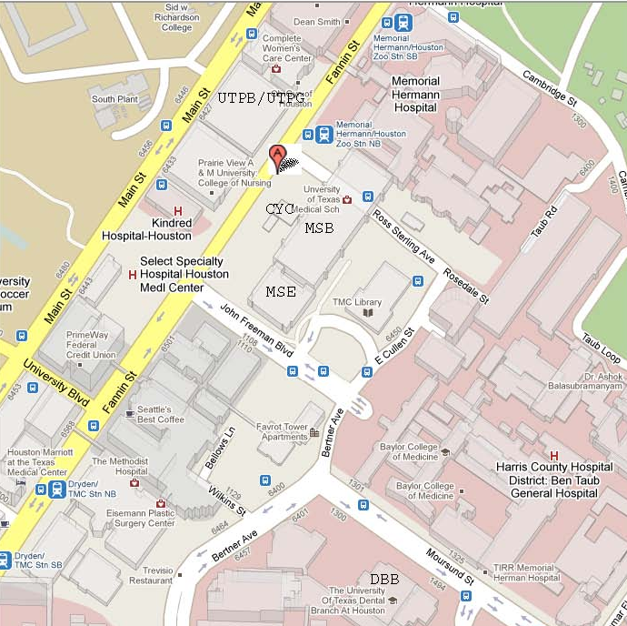

Facility locations in this image:
MSB – Medical School Building
MSE – Medical School Expansion Building
CYC – Cyclotrone Building
UTPB – University Professional Building
UTPG – University Professional Garage

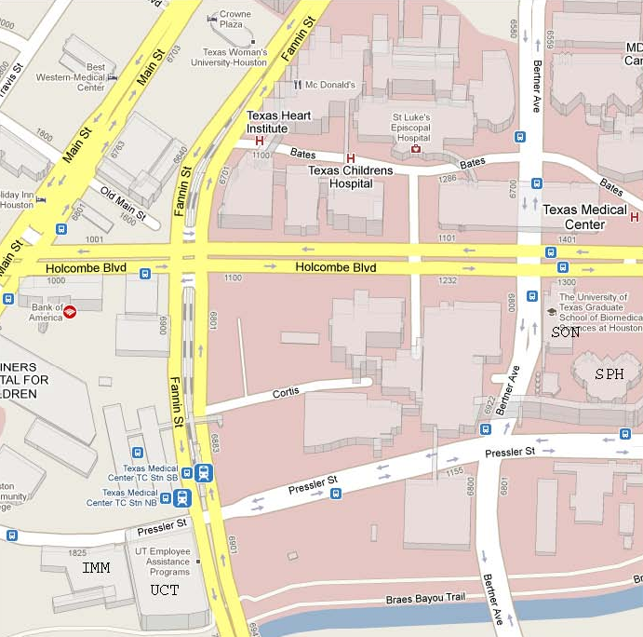

Facility locations in this image:
SON – School of Nursing
SPH – School of Public Health
UCT – University Center Tower
IMM – Institute of Molecular Imaging

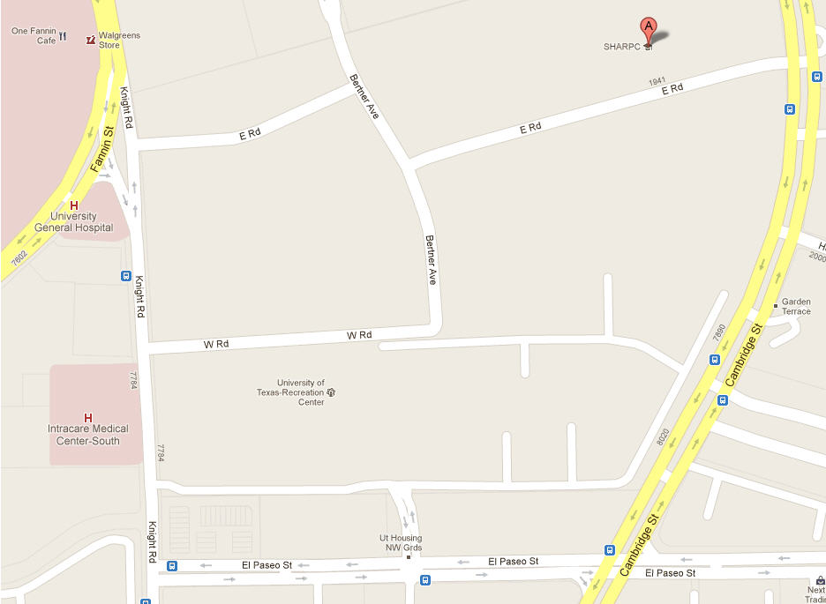
STUDENT / FACULTY HOUSING
AUX / REC
SOD
BBS

Facility locations in this image:
BBS – Behavioral & Biomedical Sciences
SOD – School of Dentistry
AUX / REC – Auxiliary Enterprises & Recreation Center
SFA – Student / Faculty Housing Complex

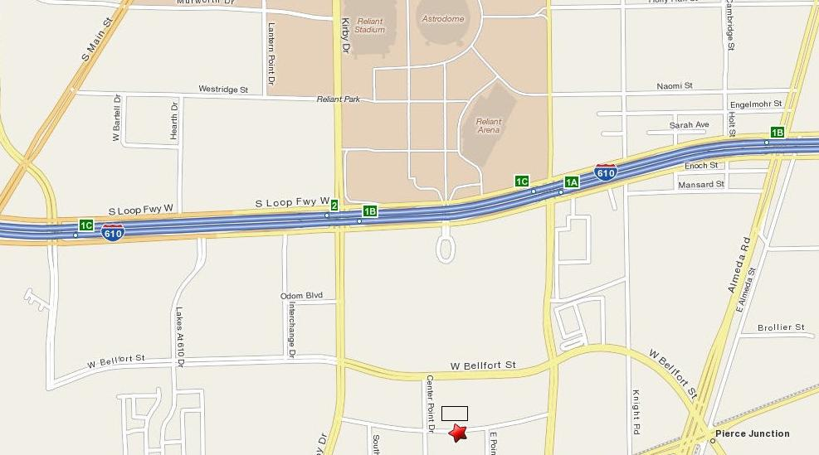

Facility locations in this image:
OCB – Operations Center Building

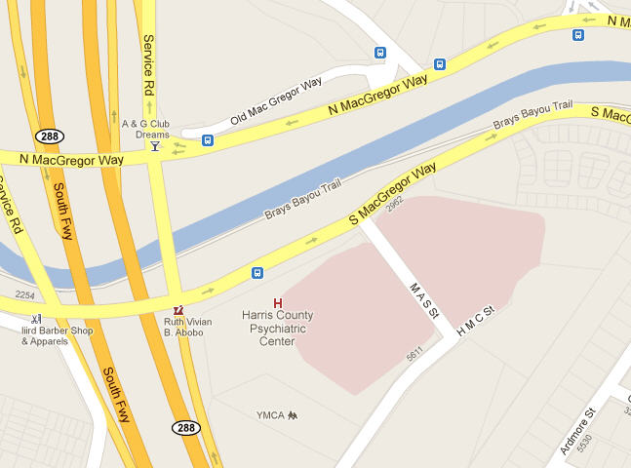
HCPC
Facility locations in this image:
HCPC – Harris County Psychiatric Center

APPENDIX FIVE

OFPC STANDARD SPECIFICATION

SECTION 23 05 93

SYSTEM TESTING, ADJUSTING AND BALANCING

This Standard Specification Section is controlled by the Office of Facilities Planning and Construction, The University of Texas System. It is to be used as guideline on all UT System projects, unless deviations are approved in writing by the Project Manager. It is not to be used for bidding, permitting, construction or any other purpose. This document is the property of UT System, and use of this document, in part or in whole, for any purpose other than for a UT System project may not be done without written permission of UT System.

To receive current updates of standard specification sections, please go to the OFPC Intranet web site at: www.utsystem.edu/fpc or contact the Office of Facilities Planning and Construction.

The issuance and revision history of this section is tabulated below. Please destroy any previous copy in your possession.

Rev No. | Date | Pages | Remarks
0 | May 1994 | 14 | Original
1 | May 2004 |  | Revised Cover Page
2 | February 2007 | 14 | Format, 1.00
3 | July 2010 | 3 | 1.00, 1.03, 1.05

PART 1 GENERAL

1.00 The following sections are to be included as if written herein:

A. 23 00 00 -- Basic Mechanical Requirements

B. 23 05 29 -- Sleeves, Flashings, Supports and Anchors

C. 23 05 53 -- Mechanical Identification

D. 23 36 00 – Air Terminal Units (VAV)

E. 23 36 00.A – Air Terminal Units (FPVAV)

F 23 73 23 – Air Handling Units

1.01 SUMMARY

A. Testing, adjusting and balancing (TAB) of the air conditioning systems and related ancillary equipment will be performed by an impartial technically qualified TAB firm selected and employed by the Owner, separate and apart from the construction contract.

B. The firm shall be capable of performing the services specified at the location of the facility described within the time specified, of preparing and submitting the detailed report of the actual field work performed, and following up the basic work as may be required.

1.02 QUALIFICATIONS

A. The Firm shall be one which is organized to provide professional services of this specified type in the State of Texas and as a minimum shall have one (1) professional engineer licensed in the State of Texas, with current registration, to perform such professional services. This engineer shall be personally responsible for developing the job site data as required in the test procedures outlined in these Specifications.

B. The Firm shall have operated a minimum of five (5) years under its current Firm name, and shall be in good standing with the State of Texas, Franchise Tax Board. The firm shall submit their full incorporated name, Charter Number and Taxpayer's I.D. Number for proper verification of the firm's status.

C. The Firm shall be capable of providing a performance bond, by a bonding company licensed to do business in the State of Texas, if determined by the Owner that such a bond is required. The amount of the bond which may be required shall be equal to the cost of the proposal submitted, or in the case of more than one proposal, the sum of all such proposals and any awarded work in progress.

D. All personnel used on the job site shall be either professional engineers or engineering technicians, who shall have been permanent, full time employees of the firm for a minimum of six (6) months prior to the start of work for this specific project.

E. The TAB firm shall submit biographical data on the individual proposed who will directly supervise the TAB work, as well as other personnel scheduled to perform the technical work under the contract. It shall also submit a background record of at least five years of specialized experience in the field of air hydronic system balancing, and shall possess properly calibrated instrumentation. The supervisory personnel for the TAB firm shall be registered engineers in the mechanical field and all of the employees used in the TAB firm shall be permanent, full-time employees of the firm.

1.03 REFERENCES

A. AABC - National Standards for Testing and Balancing Heating, Ventilating, and Air Conditioning Systems, Sixth Edition, 2002.

B. ASHRAE - 2007 HVAC Applications Chapter 34: Testing, Adjusting and Balancing.

C. ANSI/ASHRAE Standard 111-2008 - Practices for Measurement, Testing, Adjusting and Balancing of Buildings, Heating, Ventilation, Air Conditioning and Refrigeration Systems.

1.04 DOCUMENTS

A. The TAB firm shall, as a requirement of the TAB contract, arrange with the Architect to compile one set of mechanical specifications, all pertinent change orders, and the following:

1. One complete set of Drawings less the structural sheets.

2. One set of mechanical floor plans of the conditioned spaces. These Drawings shall be ozalid type (blue or black on light background) reproductions to facilitate marking.

B. Approved submittal data on equipment installed, and related changes as required to accomplish the test procedures outlined in Paragraphs 1.06 through 1.10 of this Specification will be available through the Construction Inspector.

1.05 RESPONSIBILITIES OF THE TAB FIRM

A. The TAB personnel shall check, adjust, and balance the components of the air conditioning system which will result in optimal noise, temperature, and airflow conditions in the conditioned spaces of the building while the equipment of the system is operating economically. This is intended to be accomplished after the system components are installed and operating as provided for in the contract documents. It is the responsibility of the Mechanical Contractor to place the equipment into service. Variable air volume systems shall be balanced in accordance with AABC 2002 Standard, Sixth Edition.

B. Liaison and Early Inspection:

1. The TAB firm personnel on the job shall act as liaison between the Owner, Architect and Contractor. The following reviews (observations) and tests shall be performed by the TAB Agency:

a. During the design stage, before the documents are finalized, review the mechanical drawings and specifications for balanceability and provide commentary.

b. During construction, review all HVAC submittals such as control diagrams, air handling devices, etc., that pertain to commissioning work and balanceability.

c. Allow for a fixed number of trips to the project site, over and above those required for testing and balancing for inspection of installation of the mechanical piping systems, sheet metal work, temperature controls and other component parts of the heating, air conditioning and ventilating systems during the construction stage. These inspections shall be made prior to and/or at the above ceiling inspection. Commentary will be provided to the RCM of each observation.

d. Test one (1) 8" single duct terminal box for performance capability and leakage as described in Section 23 36 00. The shipment of the box to the TAB Agency's lab will be at the manufacturer's cost and the test period will be for three (3) weeks from receipt of the box. Submittal data will not be approved until box testing passes. If the sample box is rejected for any reason the second test will be at the Contractor's cost and the time allowed will restart when the box is received at the TAB Agency.

e. Test one (1) 8" dual duct box for performance capability and leakage as described in Section 23 36 00. The shipment of the box to the TAB Agency's lab will be at the manufacturer's cost and the test period will be for three (3) weeks from receipt of the box. Submittal data will not be approved until box testing passes. If the sample box is rejected for any reason the second test will be at the Contractor's cost and the time allowed will restart when the box is received by the TAB agency.

f. Test 10% of the single and dual duct boxes for casing and damper leakage when the shipment arrives at the project site. All testing (except for the initial boxes) shall be performed on site.

Boxes requiring re-testing will be charged to the Contractor at the unit price provided to the Owner.

g. Test one (1) lab configuration including fume hood with air valve, general exhaust air with air valve and supply air with air valve for performance capability through a full range of inlet pressures. The tracking capability of the exhaust air versus the supply air will be with the submitted hood sash fully open and as the sash is closed in 2" increments until fully closed. Track the three (3) valves’ response time in relation to sash movement and the lab differential.

2. During the balancing process, as abnormalities and malfunctions of equipment or components are discovered by the TAB personnel, the Construction Inspector shall be advised in writing so that the condition can be corrected by the Mechanical Contractor. The written document need not be formal, but must be understandable and legible. Data from malfunctioning equipment shall not be recorded in the final TAB report. The TAB firm shall not instruct or direct the Contractor in any of the work, but will make such reports as are necessary to the Owner.

1.06 FINAL AIR BALANCE

General: When systems are complete and ready for operation, the TAB Consultant will perform a final air balance for all air systems and record the results. The outside, supply, exhaust and return air volume for each air handling unit, supply fan and exhaust fan and the supply, exhaust or return air volume for each distribution device shall be adjusted to within +5% of the value shown on the drawings. Air handling unit and fan volumes shall be adjusted by changing fan speed and adjusting volume dampers associated with the unit. Air distribution device volume shall be adjusted using the spin-in tap damper for flexible duct connected devices and the device OBD for duct connected devices. Air distribution devices shall be balanced with air patterns as specified. Duct volume dampers shall be adjusted to provide air volume to branch ducts where such dampers are shown. The general scope of balancing by the TAB Consultant will include, but is not limited to, the following:

1. Filters: Check air filters and filter media and balance only system with essentially clean filters and filter media. The Division 23 Contractor shall install new filters and filter media prior to the final air balance.

2. Blower Speed: Measure RPM at each fan or blower to design requirements. Where a speed adjustment is required, the Division 23 Contractor shall make any required changes.

3. Ampere Readings: Measure and record full load amperes for motors.

4. Static Pressure: Static pressure gains or losses shall be measured across each supply fan, cooling coil, heating coil, return air fan, air handling unit filter and exhaust fan. These readings shall be measured and recorded for this report at the furthest air device or terminal unit from the air handler supplying that device. Static pressure readings shall also be provided for systems which do not perform as designed.

5. Equipment Air Flow: Adjust and record exhaust, return, outside and supply air CFM (s) and temperatures, as applicable, at each fan, blower and coil.
6. Coil Temperatures: Set controls for full cooling and for full heating loads. Read and record entering and leaving dry bulb and wet bulb temperatures (cooling only) at each cooling coil, heating coil and HVAC terminal unit. At the time of reading record water flow and entering and leaving water temperatures (In variable flow systems adjust the water flow to design for all the above readings).

7. Zone Air Flow: Adjust each zone of multizone units, each HVAC terminal unit and air handling unit for design CFM.

8. Outlet Air Flow: Adjust each exhaust inlet and supply diffuser, register and grille to within +5% of design air CFM. Include all terminal points of air supply and all points of exhaust. Note: For Labs and Rooms that are negative exhaust air flow shall be set to design +10% and supply to design -5%. Positive areas will have opposite tolerances.

9. Pitot Tube Traverses: For use in future troubleshooting by maintenance personnel, all exhaust ducts, main supply ducts and return ducts shall have air velocity and volume measured and recorded by the traverse method. Locations of these traverse test stations shall be described on the sheet containing the data.

10. Maximum and minimum air flow on terminal boxes.

1.07 FINAL CHILLED AND HEATING HOT WATER BALANCE

General: When systems are completed and ready for operation, the TAB Consultant will perform a final water balance for each chilled and hot water system. The general scope of balancing by the TAB Consultant will include, but not be limited to, the following:

1. Adjusted System Tests: Adjust balancing valves at each coil and heat exchanger for design flow, +5%. Adjust balancing valves at pumps to obtain design water flow. Record pressure rise across pumps and GPM flow from pump curve. Permanently mark the balanced position for each valve (Note: If discharge valves on the pumps are used for balancing record the head being restricted by the valves).

2. Temperature Readings: Read and record entering and leaving water temperature at each water coil, converter and heat exchanger. Adjust as necessary to secure design and conditions. Provide final readings at all thermometer well locations.

3. Pressure Readings: Water pressure shall be recorded at all gauge connections. Pressure readings at coils and pumps shall be related to coil and pump curves in terms of GPM flow through flow measuring status, if provided and installed, at each air handler. The flow of water through all water coils shall be adjusted by manipulating valves until the rated pressure drops across each coil is obtained and total water flow is verified by flow measuring status. For coils equipped with 3 way valves, the rated pressure drop shall first be adjusted through the coils. The bypass valve shall then be adjusted on each coil until an equal pressure drop between supply and return connections is the same as with the flow through the coil.

4. Ampere Readings: Reading and record full load amperes for each pump motor.

1.08 SOUND VIBRATION AND ALIGNMENT

A. Sound: Read and record sound levels at up to 15 locations in the building designated by the Engineer. All measurements shall be made using an Octave Band Analyzer. All tests shall be conducted when the building is quiet in the presence of the Engineer, if he so desires.

B. Vibration: Read and record vibration for all water circulating pumps, air handling units, and fans which have motors larger than 10 HP. Include equipment vibration, bearing housing vibration, foundation vibration, building structure vibration, and other tests as directed by the Engineer. Readings will be made using portable IRD (or approved equal) equipment capable of filtering out various unwanted frequencies and standard reporting forms. Maximum vibration at any point listed above, or specified, shall not exceed 1 mil on fans and 1 mil on pumps unless otherwise specified. Equipment manufacturers shall rectify all systems exceeding vibration tolerances.

1.09 TESTING OF TEMPERATURE CONTROL SYSTEMS

A. In the process of performing the TAB work, the TAB Agency shall:

1. Work with the temperature control contractor to ensure the most effective total system operation within the design limitations, and to obtain mutual understanding of intended control performance.

2. Verify that all control devices are properly connected.

3. Verify that all dampers, valves and other controlled devices are operated by the intended controller.

4. Verify that all dampers and valves are in the position indicated by the controller (open, closed or modulating).

5. Verify the integrity of valves and dampers in terms of tightness of close-off and full-open positions. This includes dampers in multizone units, terminal boxes and fire/smoke dampers.

6. Observe that all valves are properly installed in the piping system in relation to direction of flow and location.

7. Observe the calibration of all controllers.

8. Verify the proper application of all normally opened and normally closed valves.

9. Observe the locations of all thermostats and humidistats for potential erratic operation from outside influences such as sunlight, drafts or cold walls.

10. Observe the locations of all sensors to determine whether their position will allow them to sense only the intended temperatures or pressures of the media. Control Contractor will relocate as deemed necessary by the TAB Agency.

11. Verify that the sequence of operation for any control mode is in accordance with approved shop drawings and specifications. Verify that no simultaneous heating and cooling occurs.

12. Verify that all controller setpoints meet the design intent.

13. Check all dampers for free travel.

14. Verify the operation of all interlock systems.

15. Perform variable volume system verification to assure the system and its components track with changes from full flow to minimum flow.

B. A systematic listing of the above testing and verification shall be included in the final TAB report.

1.10 STAIRWELL PRESSURIZATION SYSTEMS

A. With all doors closed, measure the door pull to determine that the opening force required is below 30 #/ft.

B. With all doors closed, measure the pressure differential across each door to verify the pressure differentials at each floor.

C. Measure the air flow in the stairwell with the maximum number of doors fully open by pitot tube traverse, if traverse locations are available. If traverse locations are not available, measure air flow at each outlet.

D. Verify with smoke that the smoke detector in the stair pressurization fan inlet shuts the fan down.

1.11 REPORTS

A. The activities described in this section shall culminate in a report to be provided in quadruplicate (4) individually bound to the RCM. Neatly type and arrange data. Include with the data the date tested, personnel present, weather conditions, nameplate record of test instrument and list all measurements taken after all corrections are made to the system. Record all failures and corrective action taken to remedy incorrect situation. The intent of the final report is to provide a reference of actual operating conditions for the Owner's operations personnel.

B. All measurements and recorded readings (of air, water, electricity, etc.) that appear in the reports must have been made onsite by the permanently employed technicians or engineers of the firm.

C. At the option of the Construction Inspector, all data sheets tabulated each day by TAB personnel shall be submitted for initial by the Construction Inspector. Those work sheets so initialed, or copies thereof, shall be presented as a supplement to the final TAB report.

D. Submit reports on forms approved by the Owner & Engineer which will include the following information as a minimum:

1. Title Page

a) Company Name
b) Company Address
c) Company telephone number
d) Project name
e) Project location
f) Project Manager
g) Project Engineer
h) Project Contractor
i) Project Identification Number

2. Instrument List

a) Instrument
b) Manufacturer
c) Model
d) Serial Number
e) Range
f) Calibration date
g) What test instrument was used for

3. Fan Data (Supply and Exhaust)

a) Location
b) Manufacturer
c) Model
d) Air flow, specified and actual
e) Total static pressure (total external), specified and actual
f) Inlet pressure
g) Discharge pressure
h) Fan RPM

4. Return Air/Outside Air Data (If fans are used, same data as for 3 above)

a) Identification/location
b) Design return air flow
c) Actual return air flow
d) Design outside air flow
f) Return air temperature
g) Outside air temperature
h) Required mixed air temperature
i) Actual mixed air temperature

5. Electric Motors

a) Manufacturer
b) HP/BHP
c) Phase, voltage, amperage, nameplate, actual
d) RPM
e) Service factor
f) Starter size, heater elements, rating

6. V-Belt Drive

a) Identification/location
b) Required driven RPM
c) Driven sheave, diameter and RPM
d) Belt, size and quantity
e) Motor sheave, diameter and RPM
f) Center-to-center distance, maximum, minimum and actual

7. Duct Traverse

a) System zone/branch
b) Duct size
c) Area
d) Design velocity
e) Design air flow
f) Test velocity
g) Test air flow
h) Duct static pressure
i) Air temperature
j) Air correction factor

8. Air Monitoring Station Data

a) Identification/location
b) System
c) Size
d) Area
e) Design velocity
f) Design air flow
g) Test velocity
h) Test air flow

9. Air Distribution Test Sheet

a) Air terminal number
b) Room number/location
c) Terminal type
d) Terminal size
e) Area factor
f) Design velocity
g) Design air flow
h) Test (final) velocity
i) Test (final) air flow

10. Pump Data

a) Identification/number
b) Manufacturer
c) Size/model
d) Impeller
e) Service
f) Design flow rate, pressure drop, BHP
g) Actual flow rate, pressure drop, BHP
h) Discharge pressure
i) Suction pressure
j) Total operating head pressure
k) Shut off, discharge and suction pressure
l) Shut off, total head pressure
m) Pressure differential settings

11. Cooling Coil Data

a) Identification/number
b) Location
c) Service
e) Manufacturer
f) Entering air DB temperature, design and actual
g) Entering air WB temperature, design and actual
h) Leaving air DB temperature, design and actual
i) Leaving air WB temperature, design and actual
j) Water pressure flow, design and actual
k) Water pressure drop, design and actual
l) Entering water temperature, design and actual
m) Leaving water temperature, design and actual
n. Air pressure drop, design and actual

12. Heating Coil Data

a) Identification/number
b) Location
c) Service
d) Manufacturer
e) Air flow, design and actual
f) Water flow, design and actual
g) Water pressure drop, design and actual
h) Entering water or steam temperature, design and actual
i) Leaving water temperature, design and actual
j) Entering air temperature, design and actual
k) Leaving air temperature, design and actual
l) Air pressure drop, design and actual

13. Sound Level Report

a) Location (Location established by the design engineer)
b) NC curve for eight (8) bands - equipment off
c) NC curve for eight (8) bands - equipment on

14. Vibration Test on equipment having 10 HP motors or above

a) Location of points:

1) Fan bearing, drive end
2) Fan bearing, opposite end
3) Motor bearing, center (if applicable)
4) Motor bearing, drive end
5) Motor bearing, opposite end
6) Casing (bottom or top)
7) Casing (side)
8) Duct after flexible connection (discharge)
9) Duct after flexible connection (suction)

b) Test readings:

1) Horizontal, velocity and displacement
2) Vertical, velocity and displacement
3) Axial, velocity and displacement

c) Normally acceptable readings, velocity and acceleration

d) Unusual conditions at time of test

e) Vibration source (if non-complying)

15. Control verification indicating date performed and any abnormalities identified.

a) Point Location/Description

b) EMS Readout (Setpoint and Actual)

c) Actual Readout

d) Interlocks

e) Safeties
1) VSD Normal Operation
2) VSD Bypass Operation

f) Alarms

g) Sequences of Operation

END OF SECTION

APPENDIX EIGHT

CERTIFICATE OF INTERESTED PARTIES
(Texas Ethics Commission Form 1295)

This is a sample Texas Ethics Commission’s FORM 1295 – CERTIFICATE OF INTERESTED PARTIES. Contractor must use the Texas Ethics Commission electronic filing web page (at https://www.ethics.state.tx.us/whatsnew/FAQ_Form1295.html) to complete the most current Certificate of Interested Parties form and submit the form as instructed to the Texas Ethics Commission and University. The Certificate of Interested Parties will be submitted only by Contractor to University with the signed Agreement.


